Salesian Voluntary Service in the world

AMERICA

UNITED STATES

NEW ROCHELLE - NY –(SUE)

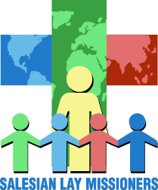

www.salesianlaymissioners.org

slm@salesianmissions.org

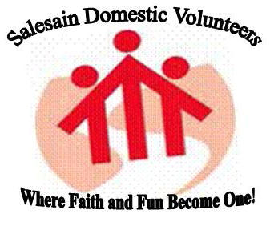

www.salesianym.com

sdv@salesianym.com

SAN FRANCISCO (SUO)
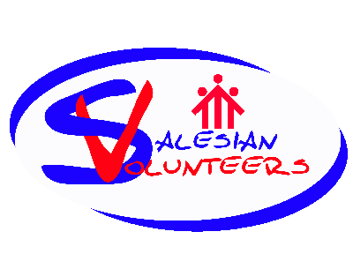

www.salesianvolunteers.org
jc@salesianvolunteers.org

BRAZIL
São Paolo (BSP)

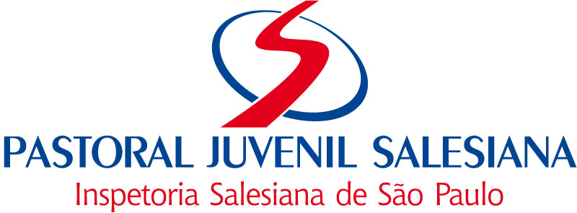

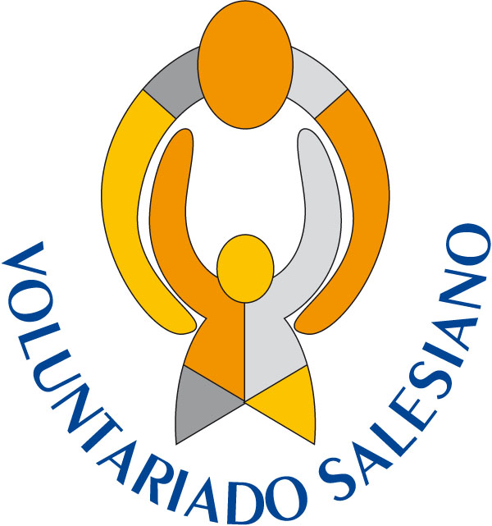

www.salesianos.com.br
pastoral@salesianos.com.br

Brasil, Nordeste (BRE)
AMS - Animação Missionária Salesiana
www.inspetoriasalesiana.org.br

ECUADOR - (ECU)

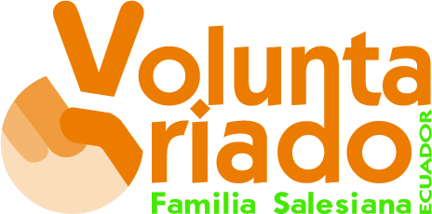

www.salesianos.org.ec
jcardenas@salesianos.org.ec

BOLIVIA (BOL)
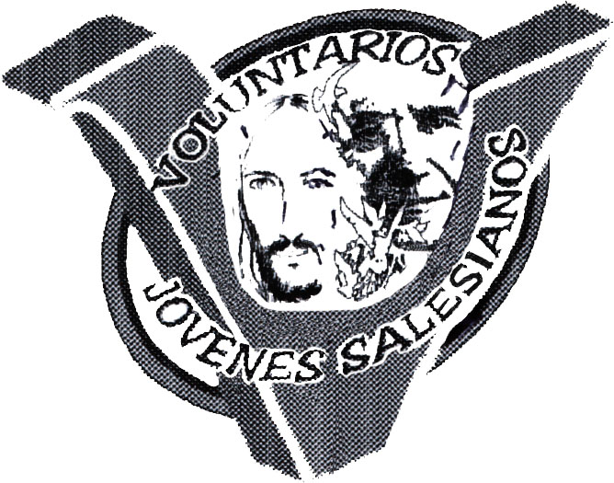
Voluntariado Juvenil Salesiano
"Sentir al mundo con un corazón inteligente
para transformarlo..."

www.sdb-bolivia.org
inspectoria@sdb-bolivia.org

CHILE (CIL)
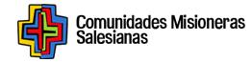

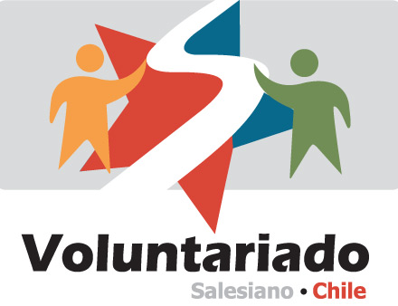
www.salesianos.cl
voluntariado@salesianos.cl

EUROPE

ITALY
ROME (CISI) – National Centre

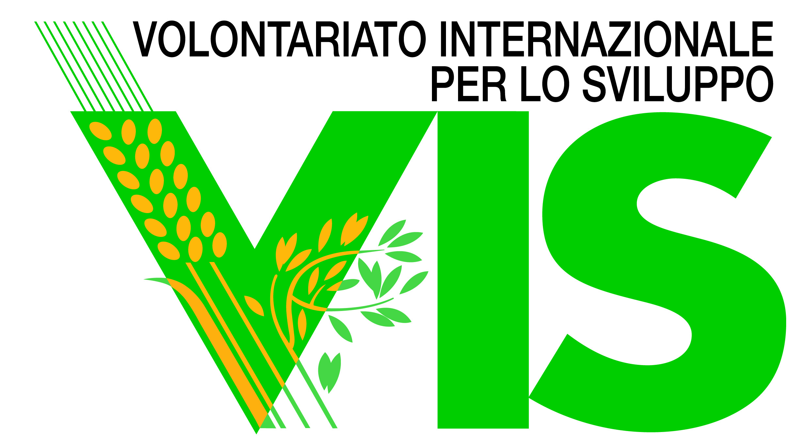

www.volint.it/
vis@volint.it

SPAIN
MADRID (SMA)- National Centre



www.jovenesydesarrollo.org
isaacdiez@jovenesydesarrollo.org

BARCELONA (SBA)
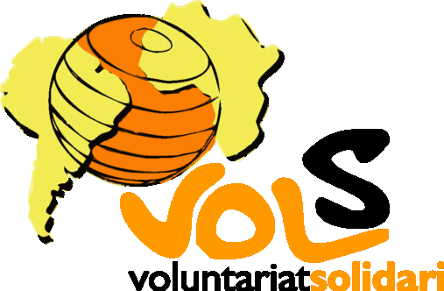

www.ongvols.org
vols@ongvols.org

SEVILLA (SSE)

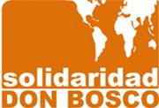

www.solidaridaddonbosco.org

GERMANY (GER)


www.donboscovolunteers.org
volunteers@donbosco.de
kirchner@donboscovolunteers.de

AUSTRIA (AUS)


www.jugendeinewelt.at
info@jugendeinewelt.at

POLAND – WARSAW (PLE) – National Centre

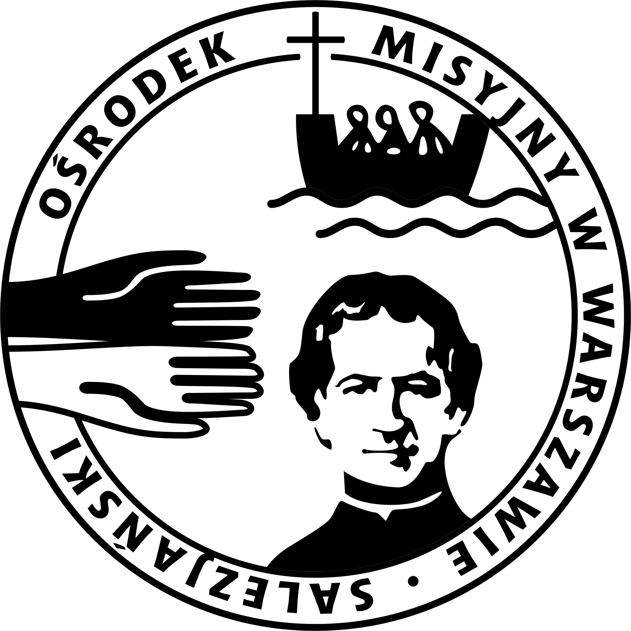
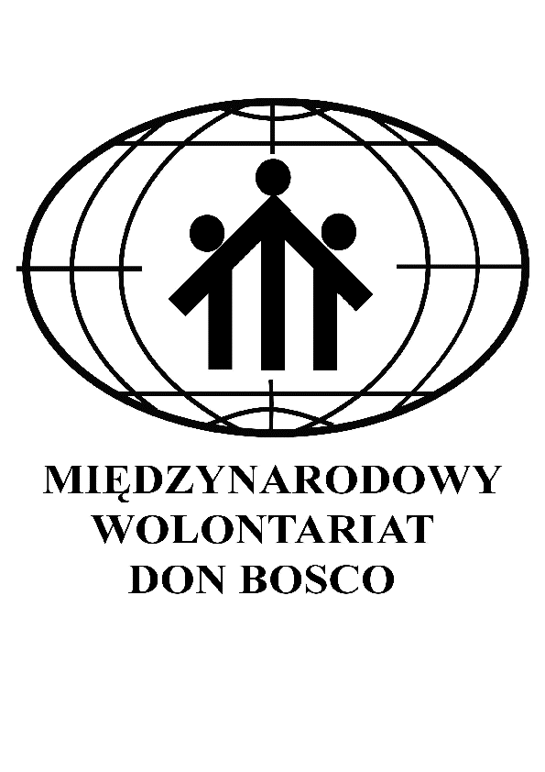
www.wolontariat.salezjanie.pl
wolontariat@salezjanie.pl
POLAND – KRAKOW (PLS)


www.swm.pl
misje@swm.pl

POLAND - PILA (PLN)

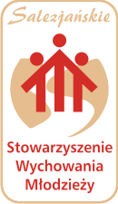

www.sswm.org
prezes@sswm.org
PORTUGAL (POR)
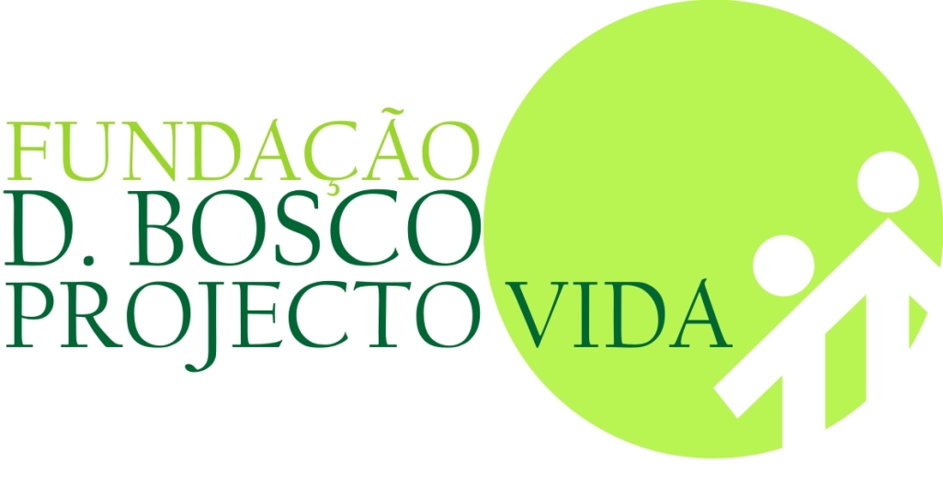

www.fundacao.salesianos.pt
fundacao@salesianos.pt
CZECH REPUBLIC (CEP)

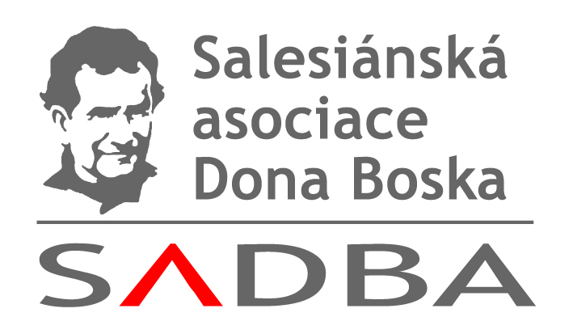

www.sadba.org
sadba@sadba.org
cagliero@sadba.org
SLOVAKIA (SLK)

www.savio.sk
savio@savio.sk
GREAT BRITAIN (GBR)
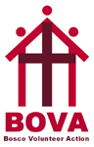

www.boscovolunteeraction.co.uk
bova@salesianyouthministry.com

ASIA AND OCEANIA

AUSTRALIA (AUL)

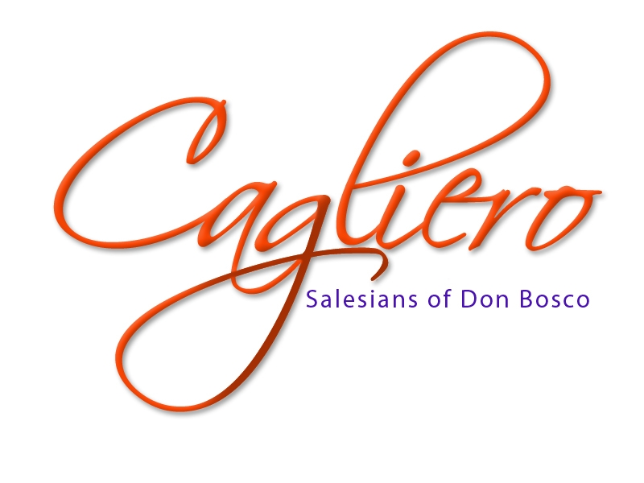
www.cagliero.org.au
lbicknell@salesians.org.au

PHILIPPINES
MAKATI –MANILA (FIN)


Salesian Lay Volunteers
www.sdb.ph
slvp_fin@yahoo.com

CEBU-TALAMBAN (FIS)
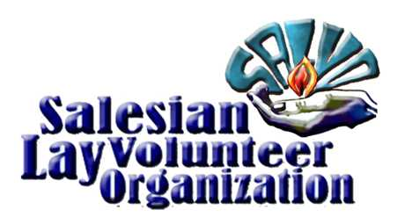
www.donbosco-fis.org
sdb@mozcom.com
JAPAN (GIA)
Don Bosco Volunteer Group

www.donboscojp.org/sdbdbvg/
www.donboscojp.org/sdbdbvg/WhatisDBVG.html
ispettoria-nipponkanku_gia@donboscojp.org

INDIA – BANGALORE (INK)

www.breadsbangalore.org
info@breadsbangalore.org
AFRICA
ANGOLA (ANG)
domboscolwena@hotmail.com
ZAMBIA (ZMB)
zmbyouthd@zmb.co.zm

